DEPARTMENT OF COMPUTER SCIENCE AND ENGINEERING

(Accredited by NBA)
RECORD OF LABORATORY WORK
25CS202 / Application Development Practices
Name of the Student :
Register No. :
Year / Branch / Section : I / CSE /
Semester : II
Academic Year : 2025 - 2026
DEPARTMENT OF COMPUTER SCIENCE AND ENGINEERING
(Accredited by NBA)

BONAFIDE CERTIFICATE
Name of the Student: . . . . . . . . . . . . . . . . . . . . . . . . . . . . . . . . . . . . . . . . . .
Register No : . . . . . . . . . . . . . . . . . . . . . . . . . . . . . . . . . . . . . . . . . . . . . . . . .

Year : . . . . . . Branch : . . . . . . . . . . Section : . . . . . . Semester : . . . . . . . .
Certified that this is the bonafide record of work done by the above student in the
25CS202 / Application Development Practices during the academic year 2025 - 2026.
Faculty Incharge HOD
Submitted for the End Semester Examination held on . . . . . . . . . . . . . .
Internal Examiner External Examiner

DEPARTMENT OF COMPUTER SCIENCE AND ENGINEERING
(Accredited by NBA)
INDEX
S.NO | LIST OF EXPERIMENTS | PAGE. NO | MARKS | SIGNATURE
1 | Create a responsive web page with a registration form using HTMLS, CSS3, and Bootstrap grid system.

2 | Enhance web elements with CSS: Shadows, Rounded Borders, and Multiple Backgrounds.
3 | Implement a CSS grid-based layout to create a responsive web page.
4 | Implement a JavaScript-based form validation for user input fields (email, password, etc.).
5 | Develop a dynamic webpage using JavaScript and DOM manipulation.
6 | Work with APIs and fetch data asynchronously using JavaScript.
7 | Create a TypeScript application demonstrating object-oriented programming concepts.
8 | Write a Linux shell script to automate file management tasks.
9 | Schedule background jobs using Linux cron and batch scripting.
10 | Perform Git version control operations: cloning, committing, branching, and merging.
11 | Collaborate on a project using GitHub: Forking, pull requests, and resolving merge conflicts.
12 | Deploy a static website using GitHub Pages.
DEPARTMENT OF COMPUTER SCIENCE AND ENGINEERING
(Accredited by NBA)

CONTINUOUS EVALUATION SHEET REFERENCES
RUBRICS TABLE
Criteria | Range of Marks
 | Excellent | Good | Average | Below Average
Aim & Algorithm (20) | 18-20 | 17-18 | 15-16 | 0-14
Program (30) | 27-30 | 21-26 | 15-20 | 0-14
Execution and Result (30) | 27-30 | 21-26 | 15-20 | 0-14
Documentation (10) | 9-10 | 7-8 | 5-6 | 0-4
Viva (10) | 9-10 | 7-8 | 5-6 | 0-4
Overall Marks (100) | 90-100 | 70-89 | 50-69 | 0-49
DEPARTMENT OF COMPUTER SCIENCE AND ENGINEERING

(Accredited by NBA) RUBRICS BASED ASSESSMENT SHEET
Name of the Lab:
Reg. No.:
Name of the Student:
Components | EX1 | EX2 | EX3 | EX4 | EX5 | EX6 | EX7 | EX8 | EX9 | EX10 | EX11 | EX12
Aim& Algorithm (20 Marks)
Program (30 Marks)
Execution and
Result
(30 Marks)
Documentation (10 Marks)
Viva (10 Marks)
TOTAL
 |  |  |  |  |  | Consolidated Mark (100)
 |  |  |  |  |  | Faculty Signature

Exp 1: Create a responsive web page with a registration form using HTMLS, CSS3, and Bootstrap grid system.

Aim:
To create a responsive web page with a registration form using HTML5, CSS3, and the Bootstrap grid system, ensuring proper layout, styling, and adaptability across different screen sizes.
Algorithm:
- Start the program.
- Create HTML structure:
Use <!DOCTYPE html> and basic HTML5 tags (<html>, <head>, <body>).
Add meta viewport tag for responsiveness.
- Link external resources:
Include Bootstrap CSS using CDN.
Link a custom CSS file for additional styling.
- Design layout using Bootstrap grid:
Create a container (.container or .container-fluid).
Use rows (.row) and columns (.col-md-, .col-lg-) to structure the form.
- Create registration form:
Add form element <form>.
Include input fields such as:
  - Name
  - Email
  - Password
  - Confirm Password
  - Phone Number
Use Bootstrap classes like .form-control for styling.
- Add labels and placeholders:
Provide labels for each input field.
Use placeholders for better user guidance.
- Apply validation (optional):
Use HTML5 validation attributes like required, type="email".
- Style the page using CSS3:
Customize colors, spacing, fonts.
Add responsiveness improvements if needed.
- Add submit button:
Use Bootstrap button classes like .btn and .btn-primary.
- Test responsiveness:
Check layout on different screen sizes (mobile, tablet, desktop).
- End the program.

Program:
<!doctype html>
<html>

<head>
<link href="https://cdn.jsdelivr.net/npm/bootstrap@5.3.3/dist/css/bootstrap.min.css" rel="stylesheet">
<script src="https://cdn.jsdelivr.net/npm/bootstrap@5.3.3/dist/js/bootstrap.bundle.min.js"></script>
</head>

<body>
<div class="container-fluid bg-dark text-white text-center ">
<i>Shaine Athena B</i>
</div>
<nav class="navbar navbar-expand-sm navbar-dark bg-dark ">
<div class="container-fluid">
<a class="navbar-brand" href="javascript:void(0)">Shaine Athena B</a>
<button class="navbar-toggler" type="button" data-bs-toggle="collapse" data-bs-target="#mynavbar">
<span class="navbar-toggler-icon"></span>
</button>
<div class="collapse navbar-collapse" id="mynavbar">
<ul class="navbar-nav me-auto">
<li class="nav-item">
<a class="nav-link" href="#education">Education</a>
</li>
<li class="nav-item">
<a class="nav-link" href="#pro">Projects</a>
</li>
<li class="nav-item">
<a class="nav-link" href="#ach">Acheivements</a>
</li>
<li class="nav-item">
<a class="nav-link" href="javascript:void(0)">contact </a>
</li>
</ul>

</div>
</div>
<img
src="C:\Users\Hp\Downloads\Photo.png"
class="img-fluid rounded-circle"
alt=""
width="40px"
/>

</nav>
<section id="education">
<div
class="table-responsive"
>
<table
class="table table-primary"
>
<thead>
<tr>
<th scope="col">Grade</th>
<th scope="col">School</th>
<th scope="col">CGPA</th>
</tr>
</thead>
<tbody>
<tr class="">
<td scope="row">X</td>
<td>Velammal</td>
<td>8.00</td>
</tr>
<tr class="">
<td scope="row">XII</td>
<td>velammal</td>
<td>8.00</td>
</tr>
<tr class="">
<td scope="row">UG</td>
<td>SKCET</td>
<td>8.00</td>
</tr>
</tbody>

</table>
</div>

</section>
<section id="pro">
<div class="row">

<div class="col border text-center">
<h3>project 1</h3>
<h4>student management system</h4>
<br>
A Student Management System (SMS) is a software application used by schools, colleges, or training institutes to manage student-related information and activities digitally.

</div>
<div class="col border text-center">
<h3>project 2</h3>
<h4>online library management system</h4>
<br>
An Online Library Management System is a digital platform that allows users to search, borrow, and return books. It helps librarians manage book records, track issued books, and maintain a database of available resources in the library.
</div>
<div class="col border text-center">
<h3>project 3</h3>
<h4>online quiz system</h4>
<br>
An Online Quiz System is a web application that allows students to take quizzes online. It automatically evaluates answers, calculates scores, and displays results instantly. It helps teachers conduct tests easily and track student performance.
<br><br><br>
</div>

</div>
</section>

<section id="ach">
<div id="demo" class="carousel slide" data-bs-ride="carousel">

<!-- Indicators/dots -->
<div class="carousel-indicators">
<button type="button" data-bs-target="#demo" data-bs-slide-to="0" class="active"></button>
<button type="button" data-bs-target="#demo" data-bs-slide-to="1"></button>
<button type="button" data-bs-target="#demo" data-bs-slide-to="2"></button>
</div>

<!-- The slideshow/carousel -->
<div class="carousel-inner">
<div class="carousel-item active">
<img src="C:\Users\Hp\Downloads\ach.png" alt="Los Angeles" class="d-block" style="width:100%">
</div>
<div class="carousel-item">
<img src="C:\Users\Hp\Downloads\ach1.jpg" alt="Chicago" class="d-block" style="width:100%">
</div>
<div class="carousel-item">
<img src="C:\Users\Hp\Downloads\ach.png" alt="New York" class="d-block" style="width:100%">
</div>
</div>

<!-- Left and right controls/icons -->
<button class="carousel-control-prev" type="button" data-bs-target="#demo" data-bs-slide="prev">
<span class="carousel-control-prev-icon"></span>
</button>
<button class="carousel-control-next" type="button" data-bs-target="#demo" data-bs-slide="next">
<span class="carousel-control-next-icon"></span>
</button>
</div>

<div class="container-fluid mt-3">

</div>
<form>
<input type="submit">
<br><br>
</form>
</section>

</body>
</html>

Output:
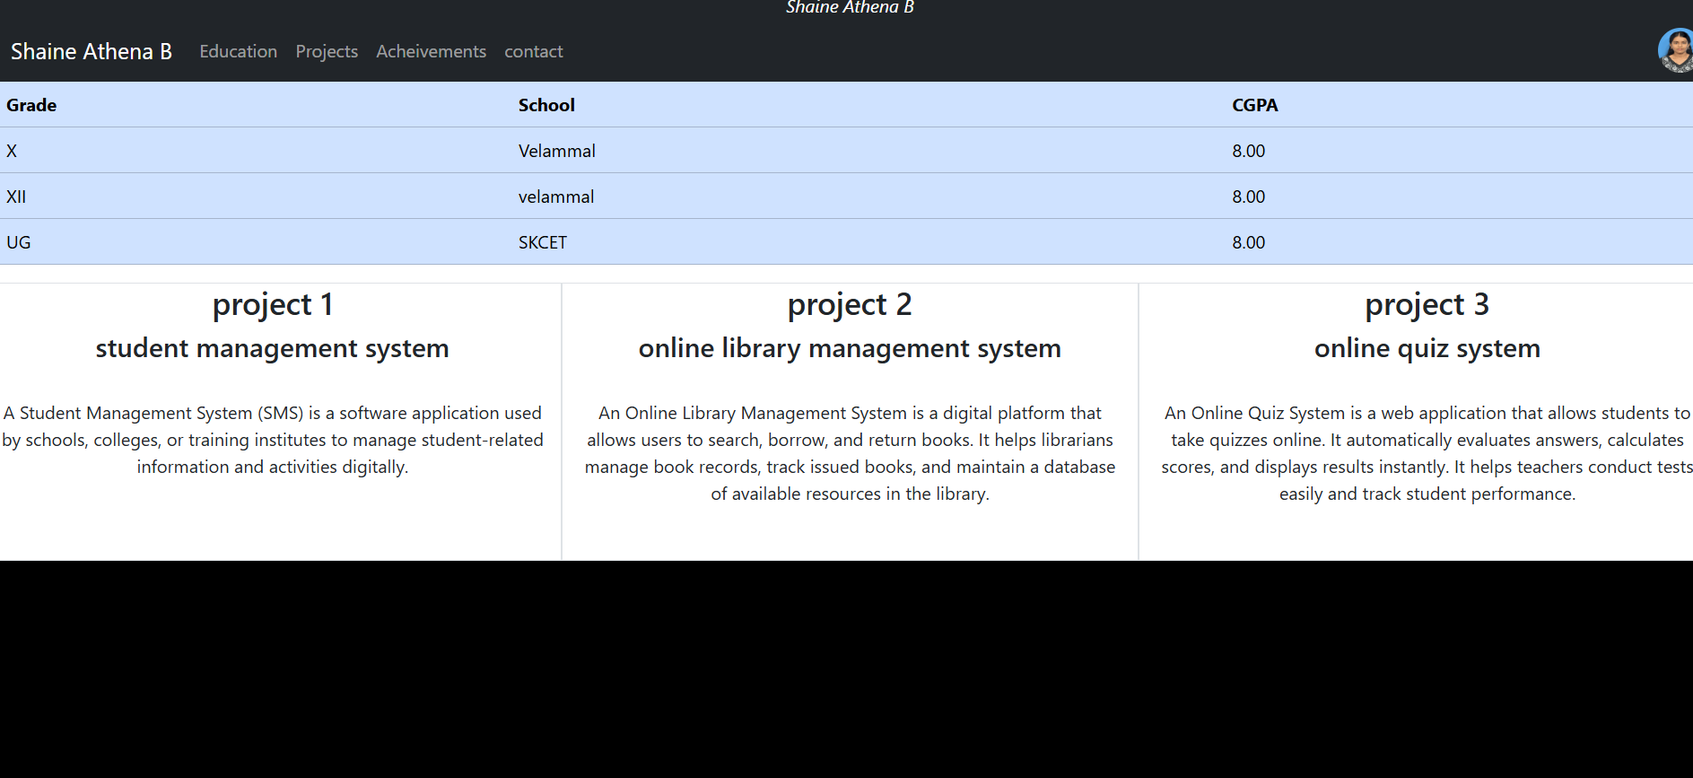


Exp 2: Enhance web elements with CSS: Shadows, Rounded Borders, and Multiple Backgrounds.

